Purpose

Reliable method to quantify DNA concentration accurately with a Qubit fluorometer.

Scope

Specifically designed to quantify DNA samples, not RNA. Accurate readings generated from this SOP are most needed when normalizing samples for qPCR or for next generation sequencing (NGS) libraries.

Responsibilities

QC team in molecular diagnostics lab (student)

Definitions
- n = samples
- DNA (Deoxyribonucleic Acid): A molecule that carries the genetic instructions used in the growth, development, functioning, and reproduction of all known living organisms and many viruses.
- RNA (Ribonucleic Acid): A molecule essential in various biological roles in coding, decoding, regulation, and expression of genes. This SOP does not cover RNA quantification.
- Qubit Fluorometer: An instrument used to measure the concentration of nucleic acids (DNA or RNA) using fluorescent dyes that bind selectively to the target molecules.
- Qubit Reagent (200x): A highly concentrated solution used to prepare the working solution for DNA quantification assays.
- Qubit Buffer: A solution used to dilute the Qubit reagent to create the working solution for the assay.
- Standard 1 and Standard 2: Known concentrations of DNA used to calibrate the Qubit fluorometer and ensure accurate measurements.
- Serological Pipette: A laboratory instrument used to measure and transfer liquids with high precision.
- Micropipettes (p2, p20, p200, p1000): Precision instruments used to transfer small volumes of liquid, specified by their maximum capacity in microliters.
- PCR Tubes (0.5 mL): Small tubes used in polymerase chain reaction (PCR) assays to hold samples and reagents during thermal cycling.
- Unknown Samples: DNA samples of unknown concentration that are to be quantified using the Qubit fluorometer.
- Conical Tube (15 mL or 50 mL): Tubes used for mixing and preparing solutions, typically with a conical bottom to facilitate the collection of precipitates.
- 1x Qubit Working Solution: A diluted form of the Qubit reagent used for the DNA quantification assay.
- PPE (Personal Protective Equipment): Equipment worn to minimize exposure to hazards that can cause serious workplace injuries and illnesses. Includes gloves, goggles, and lab jackets.

References
https://assets.thermofisher.com/TFS-Assets/LSG/manuals/Qubit_dsDNA_HS_Assay_UG.pdf

Materials

Material Description | Standard Quantity | Unit
Qubit reagent (200x) for ds DNA | 1 | ~1 mL
Qubit buffer | 1 | ~100 mL
Standard 1 | 1 | 1 mL
Standard 2 | 1 | 1 mL
Serological pipette, Micropipettes (p2, p20, p200, p1000), tips | N/A | N/A
0.5 PCR tubes (clear) | n samples +2 | tubes
Unknown samples | n | N/A
Conical tube (15 mL or 50 mL) | 1 | tube

Safety
(All safety information here)

Wear PPE: gloves, goggles, lab jacket. Refer SDS for hazards and waste disposal

Procedure

- Prepare 1x Qubit working solution if needed (store otherwise in 4C fridge) in conical tube

1.1 Figure how many samples you would like to prepare working solution for (n).
1.2 Transfer 1 uL of 200x Qubit concentrate reagent for every sample (n).
1.3 Transfer 199 uL of Qubit buffer for every sample (n).

- Prepare standards (day of)
  - In 0.5 mL PCR tube labelled 1, add 10 uL of standard tube 1 plus 190 uL of 1x Qubit working solution.
  - In 0.5 mL PCR tube labelled 2, add 10 uL of standard tube 2 plus 190 uL of 1x Qubit working solution.

- For each 0.5 mL PCR tube earmarked for one unknown sample each:
  - Label top of tube with ID.
  - Add 199 uL of 1x Qubit working solution + 1 uL of unknown sample.

- Operate Qubit Flurometer
  - Select appropriate program on screen (dsDNA > assay name (e.g. BR Qubit Assay).
  - Select option to load standards.
  - Follow prompt to load and read standard 1.
  - Follow prompt to load and read standard 2.
  - Follow prompt to load and read unknown sample.
  - Repeat step 4.5 for addition unknown sample.

Figures and Diagrams
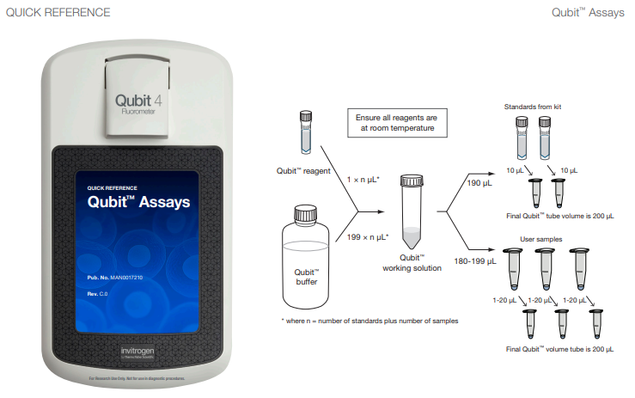
Figure 1. Manufacturer’s quick reference diagram.

Notes/Observations

Attachments
N/A

